24ADC001 — BUSINESS INTELLIGENCE FOR DECISION MAKING
Roll.number: 24BAD071 Name:Mithunjai.E

UNIT II — TOOL-BASED ASSIGNMENTS
ASSIGNMENT 1 — POWER BI

From Data Warehouse to Dashboard
Concepts covered: star schema, data modelling, OLAP operations (roll-up, drill-down, slice, dice), analytic functions.

Objective
Build a small star-schema data model in Power BI, then use it to demonstrate every core OLAP operation through interactive report visuals.

Tasks
- Import a raw, flat sales dataset into Power BI (Get Data → CSV/Excel).
- In Power Query, split the flat table into a Fact_Sales table and at least two dimension tables (e.g., Dim_Date, Dim_Product, Dim_Region).
- In Model view, build the relationships between the fact table and each dimension table — this is your star schema.
- Create a Matrix visual with Region on rows and Year/Quarter on columns. Use the drill-down arrows to demonstrate roll-up (collapse to Year) and drill-down (expand to Quarter, then Month).
- Add slicers for Category and Region, and show one view sliced to a single category and one view diced to a combination of region and category.
- Write one DAX measure using RANKX() to rank products or regions by total sales.
- Write one DAX time-intelligence measure (e.g., using DATEADD or a simple month-over-month calculation) to compare a period against the previous one.

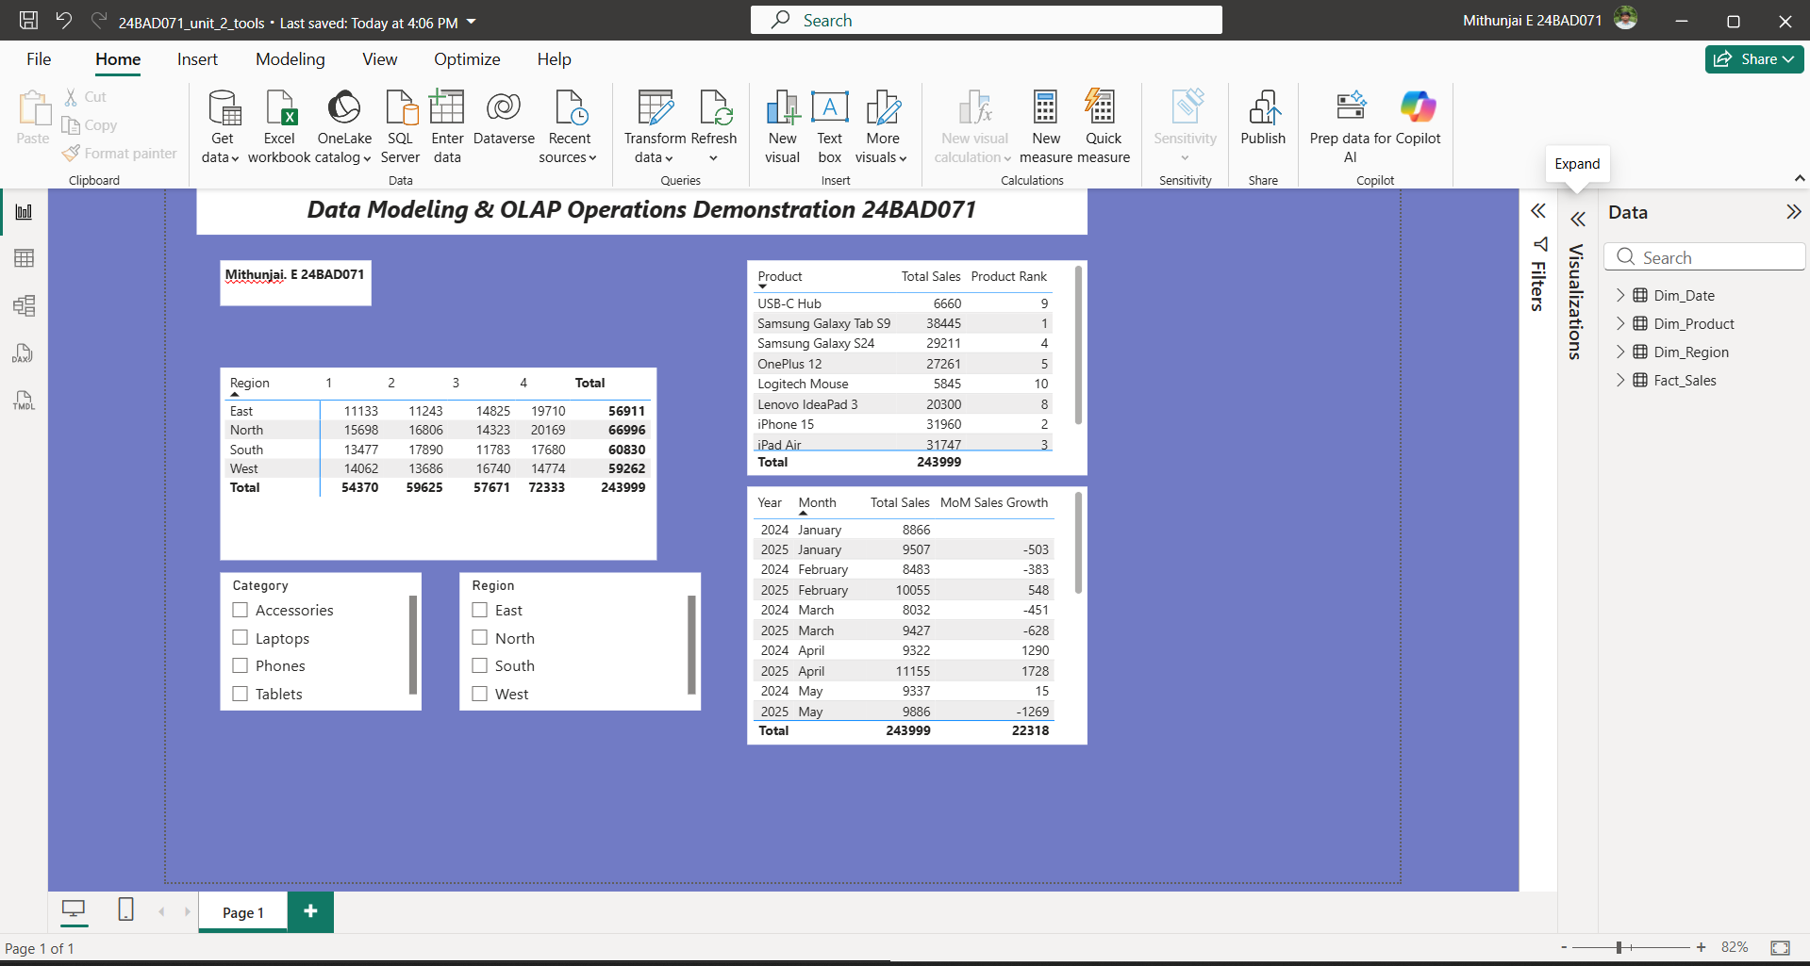

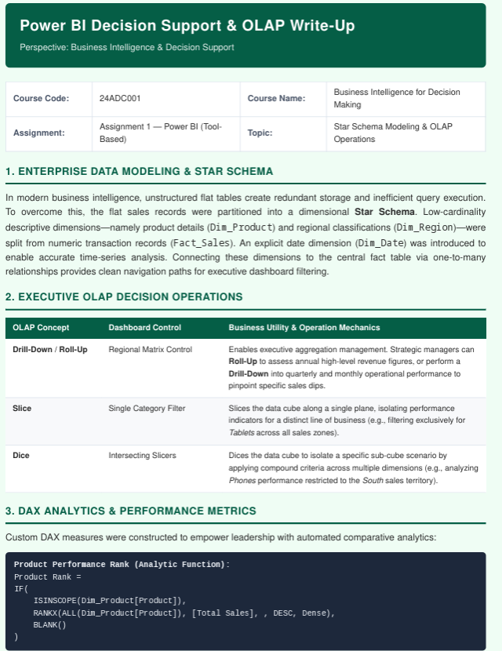

Deliverables
- The .pbix file, with the model view, matrix visual, slicers, and both DAX measures included.
- A one-page write-up (Word or PDF) explicitly naming which OLAP operation (roll-up, drill-down, slice, dice) each visual demonstrates.

Criterion | What to look for | Marks
Star schema data model | Fact and dimension tables correctly separated and related | 5
Roll-up / drill-down demo | Matrix visual genuinely expands and collapses through a hierarchy | 5
Slice and dice demo | Slicers correctly isolate a single value and a combination of values | 5
DAX: RANKX measure | Ranking measure works and is explained in the write-up | 5
DAX: time-intelligence measure | Period-over-period measure works and is explained | 5
Write-up clarity | Each visual is correctly mapped to the OLAP operation it shows | 5

ASSIGNMENT 2 — TABLEAU

Visualizing the Decision
Concepts covered: business intelligence dashboards, OLAP operations, types of decisions, decision support.

Objective
Build an interactive Tableau dashboard that a manager could genuinely use to make a decision, and identify what kind of decision it supports.

Tasks
- Connect Tableau to the sales dataset.
- Build at least three linked worksheets: one geographic view (map), one categorical breakdown (bar chart), and one trend view (line chart over time).
- On the geographic or categorical view, build a drill-down hierarchy (for example Region → State → City) and demonstrate expanding and collapsing it — roll-up and drill-down.

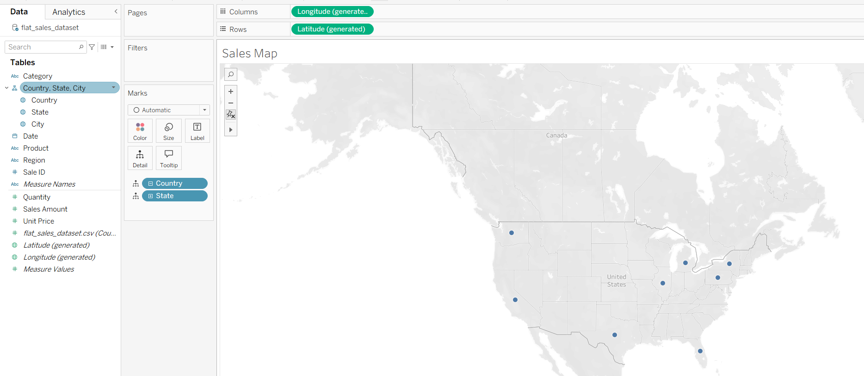
- Add at least one filter and one parameter that let a user slice to a single value and dice to a combination of values.

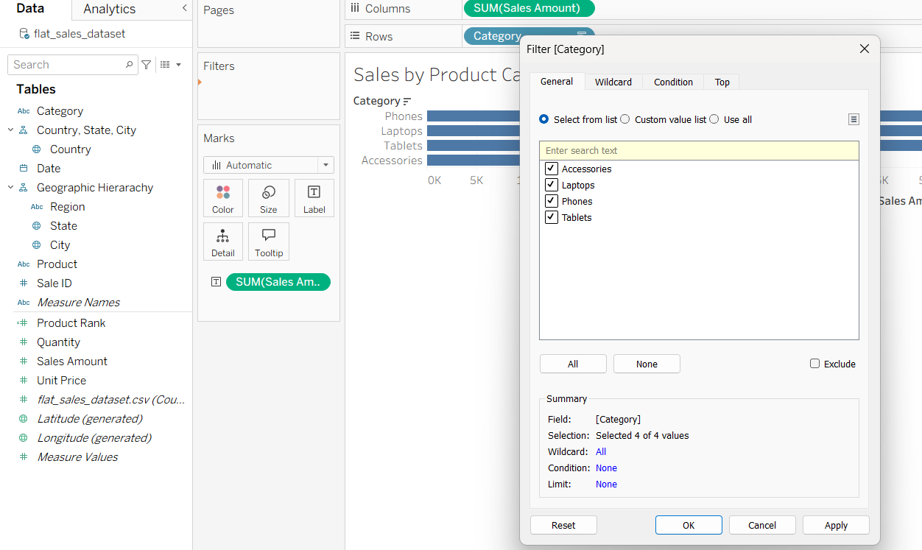
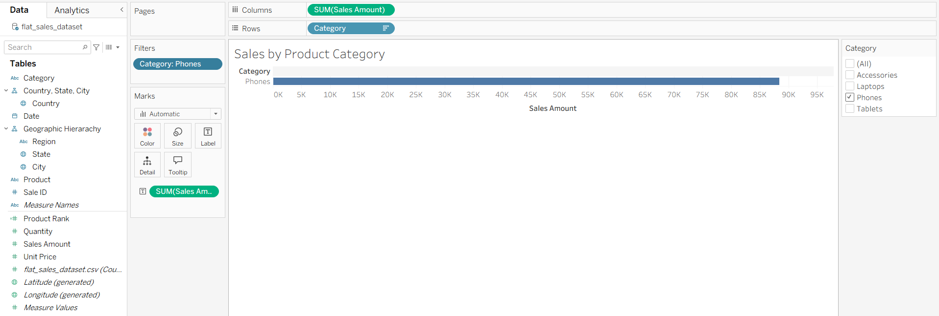
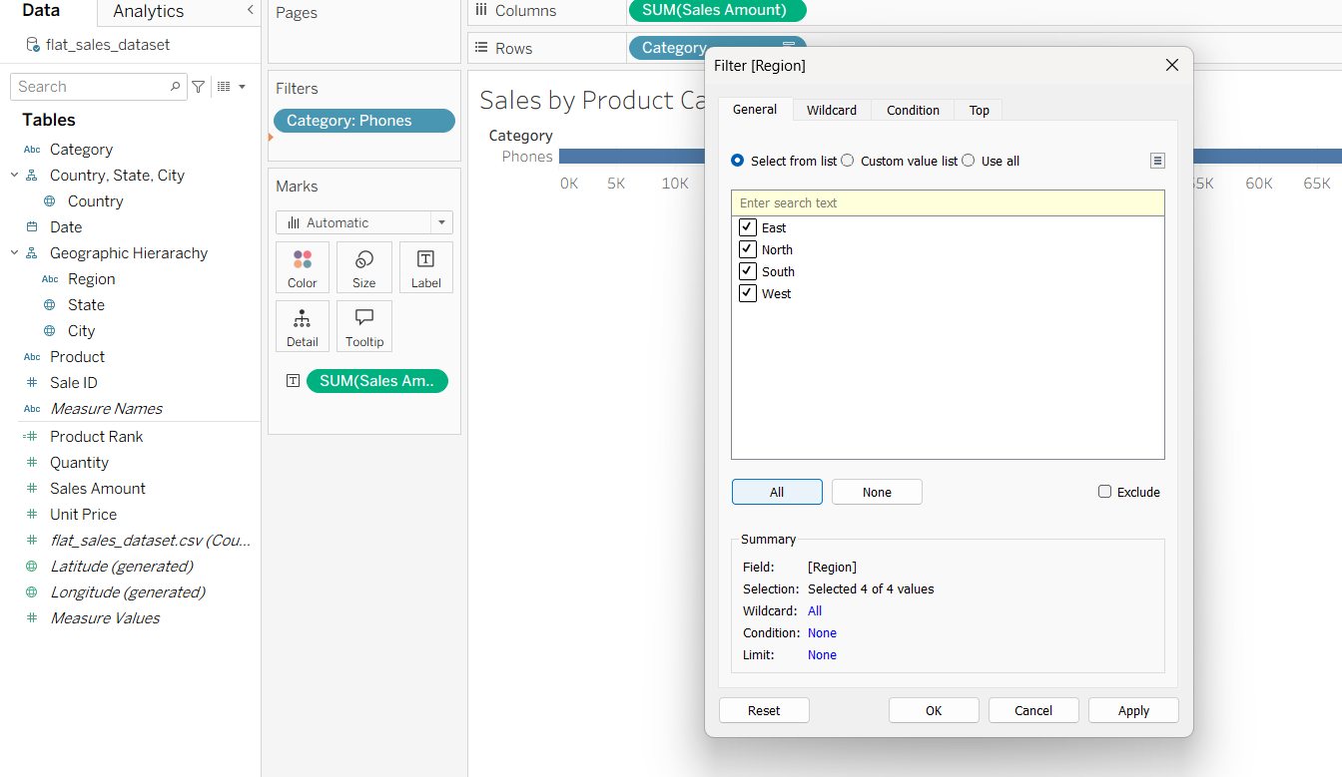

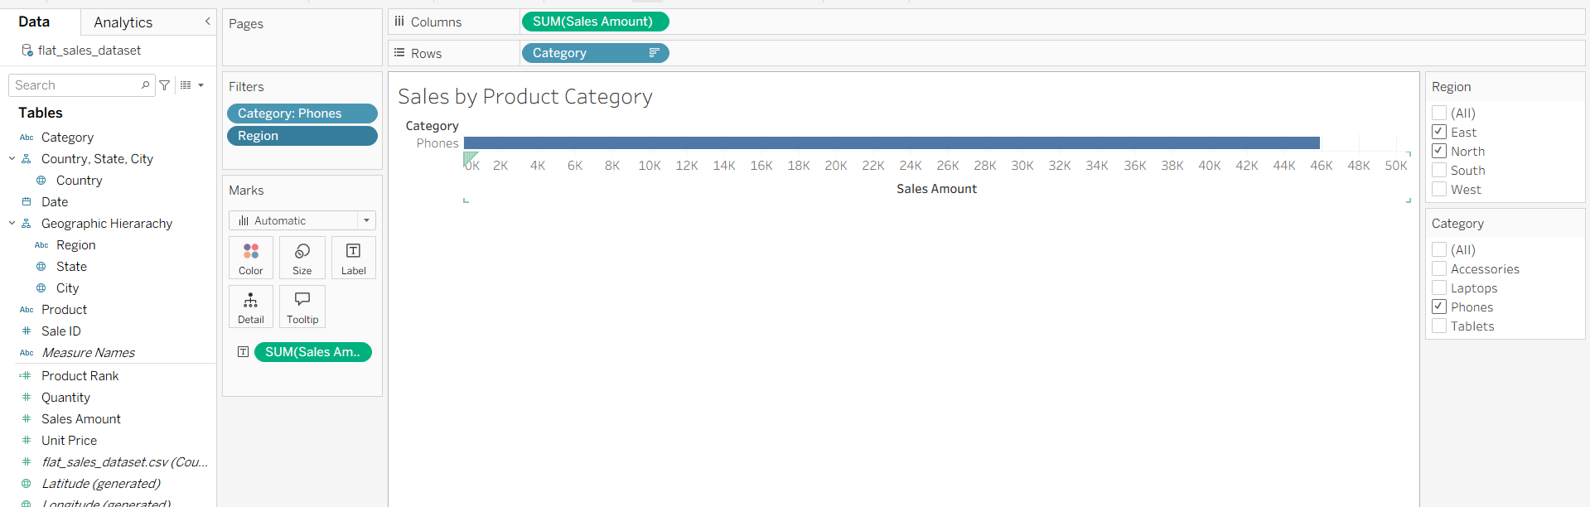

DICE ( Category: Phone, Region:South
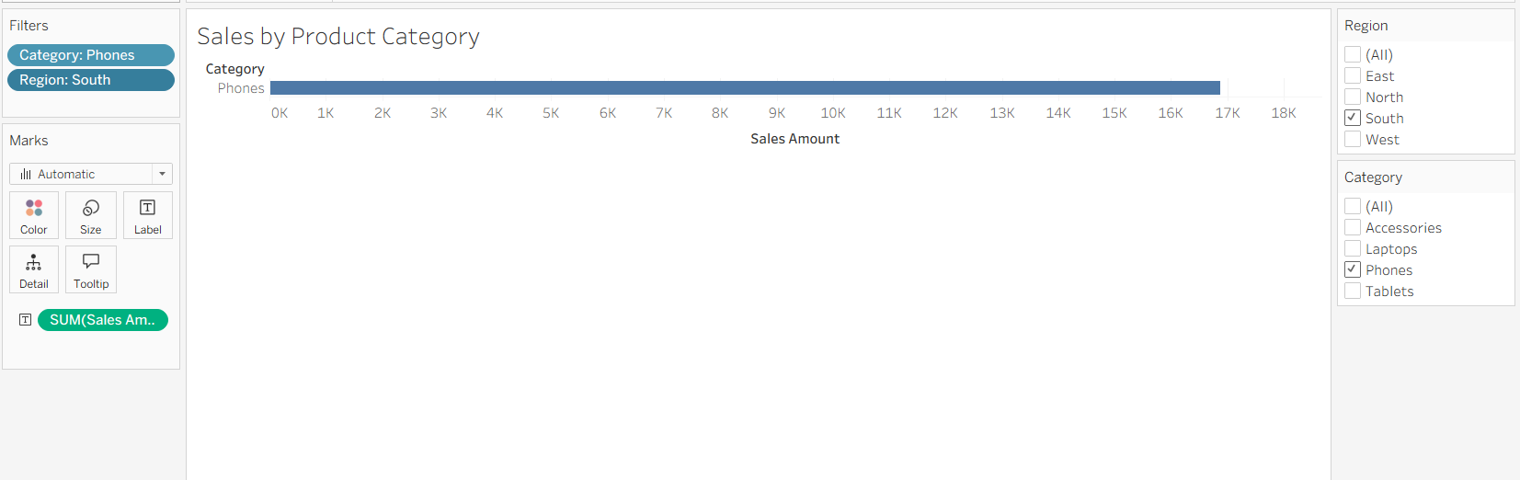
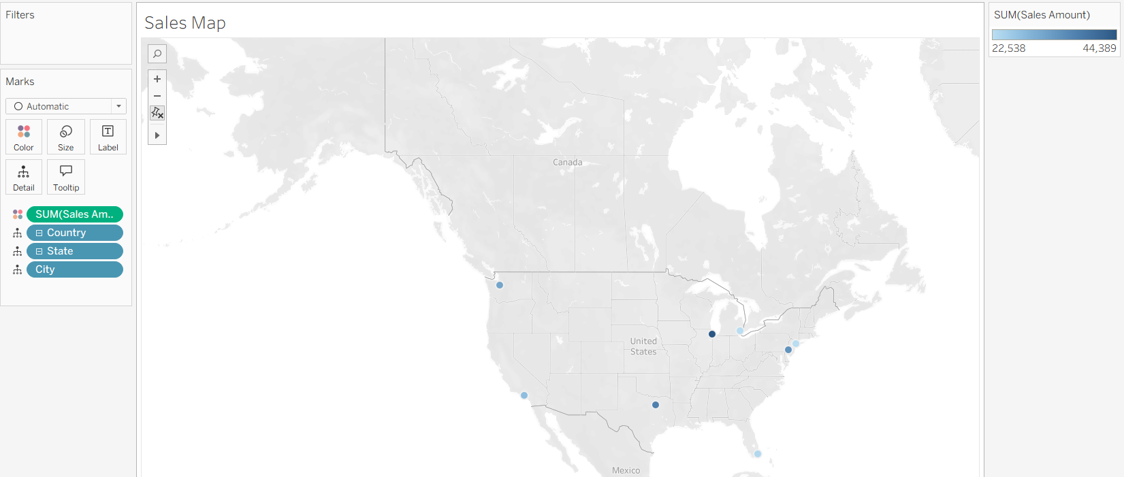

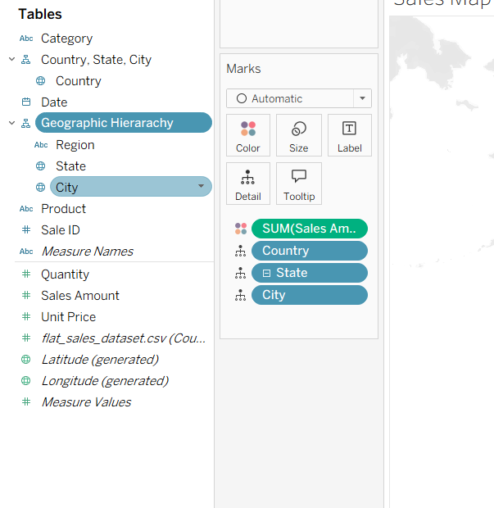

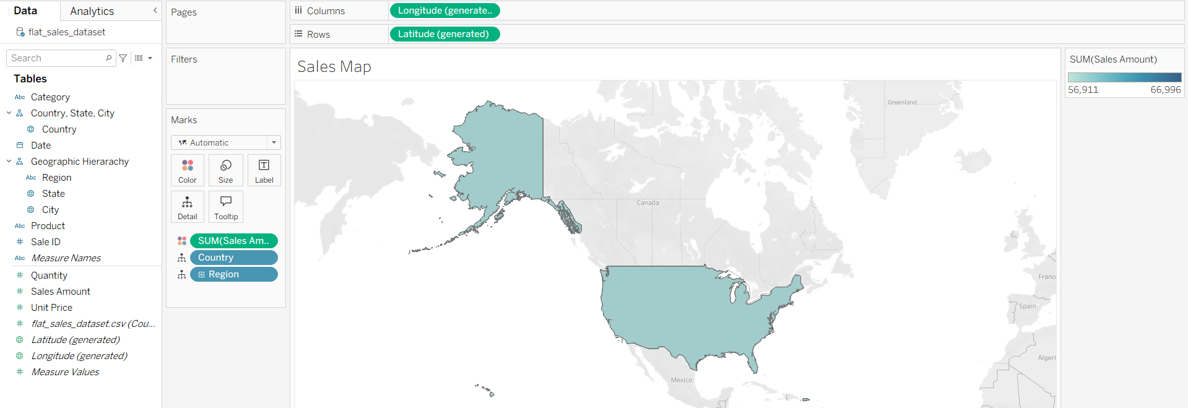
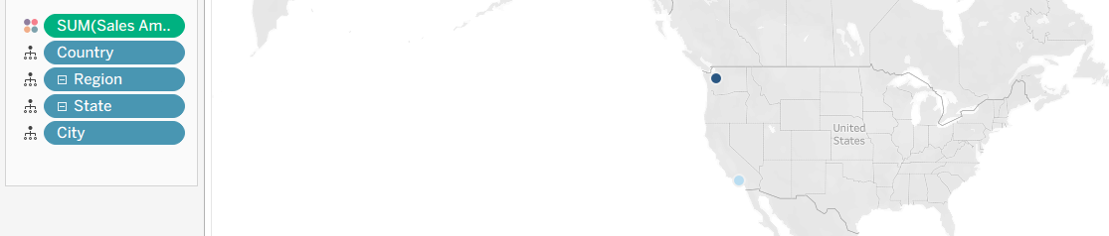

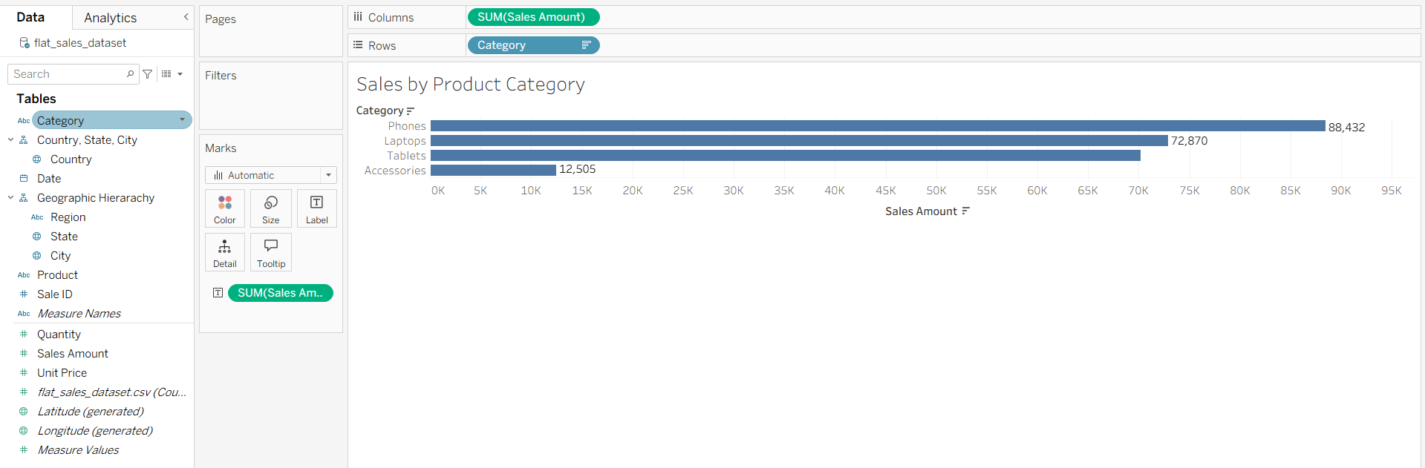
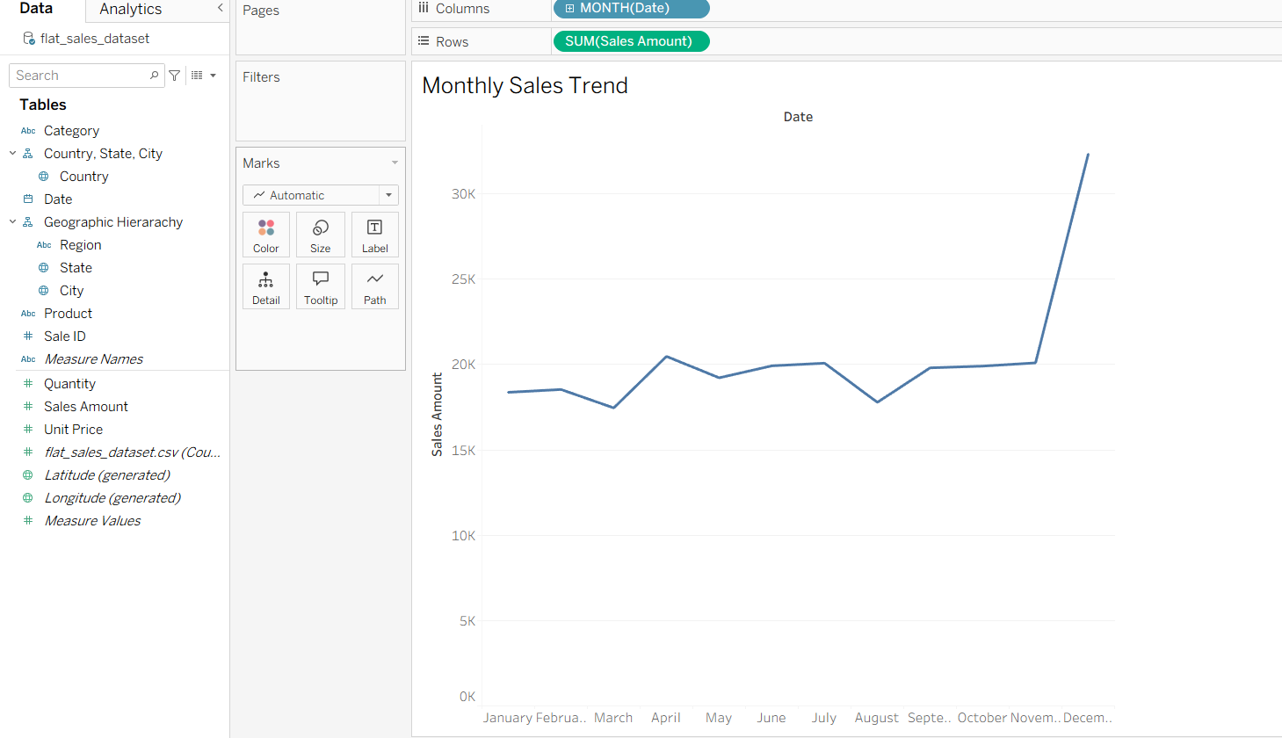

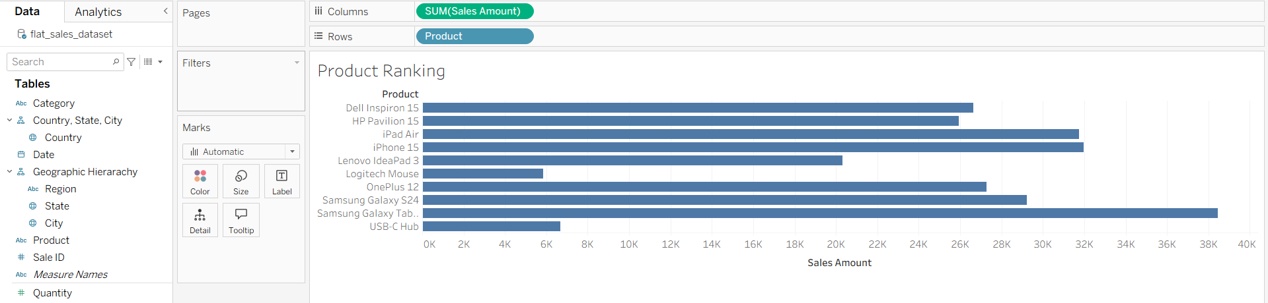

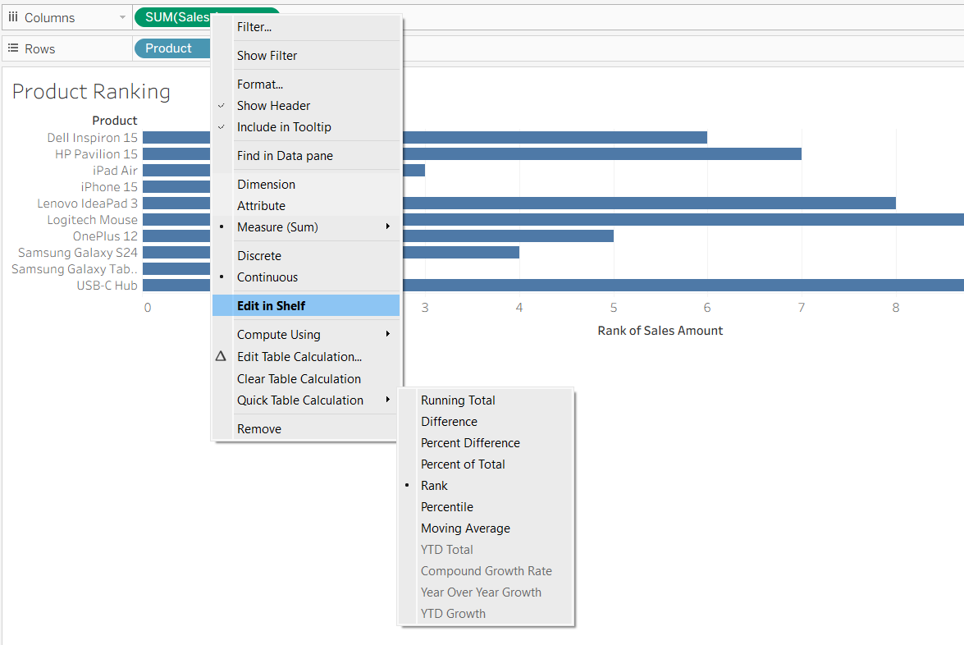

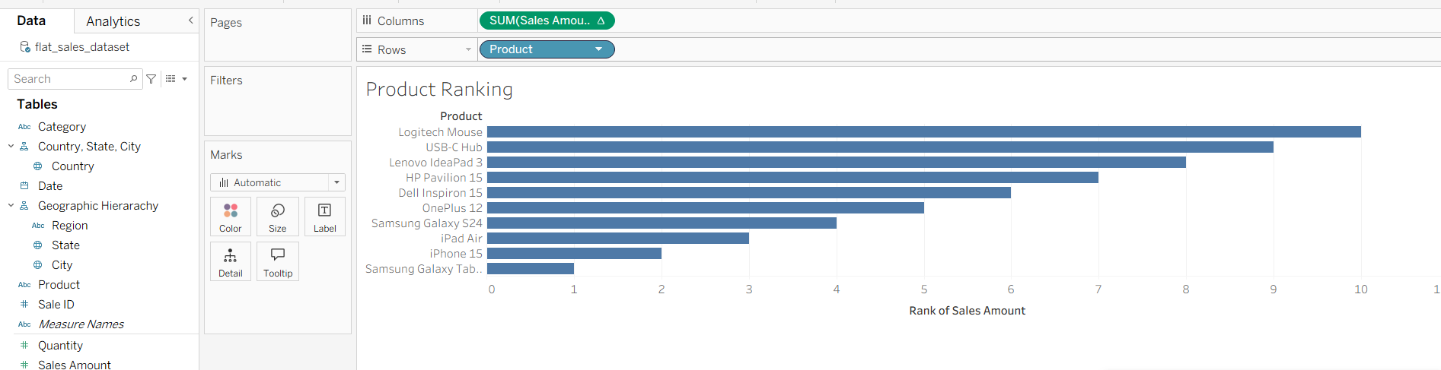

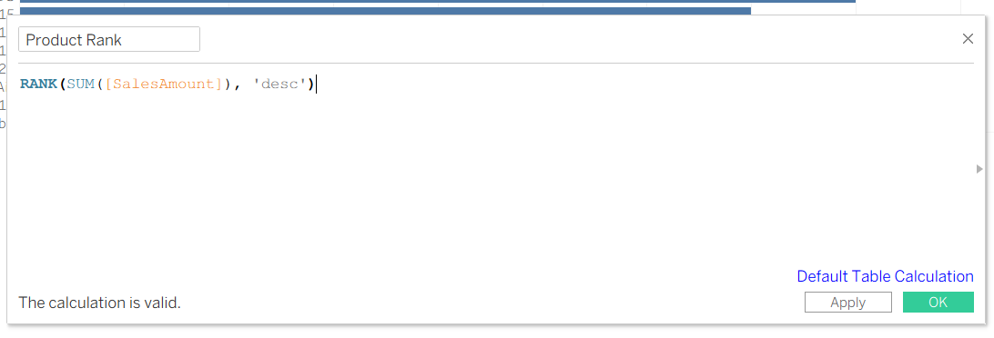

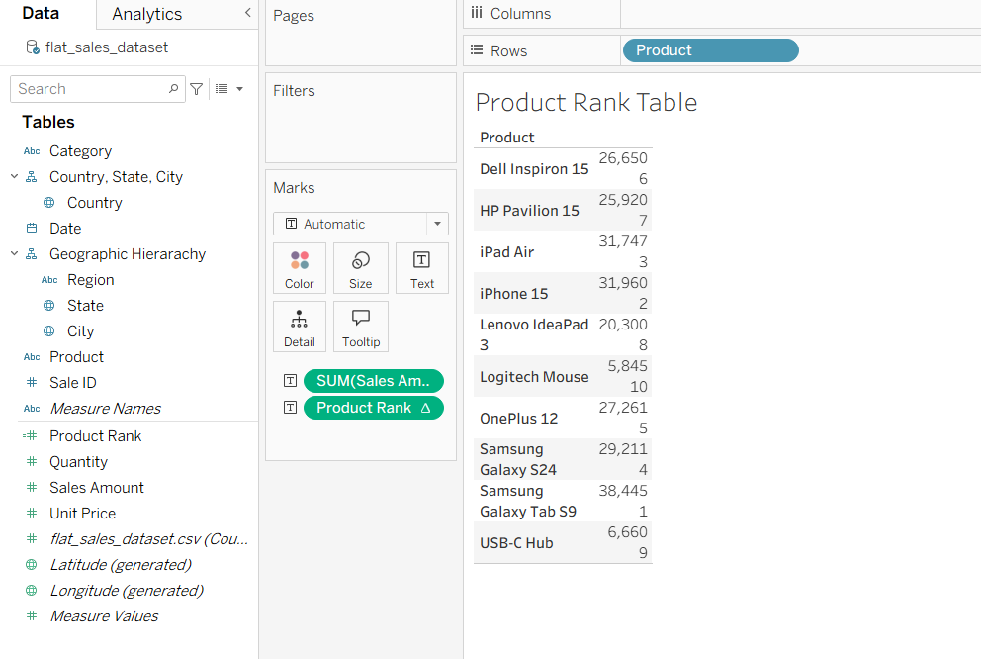

- Create a calculated field using a table calculation (e.g., RANK or RUNNING_SUM) to rank items or compute a running total — Tableau's equivalent of a SQL analytic function.
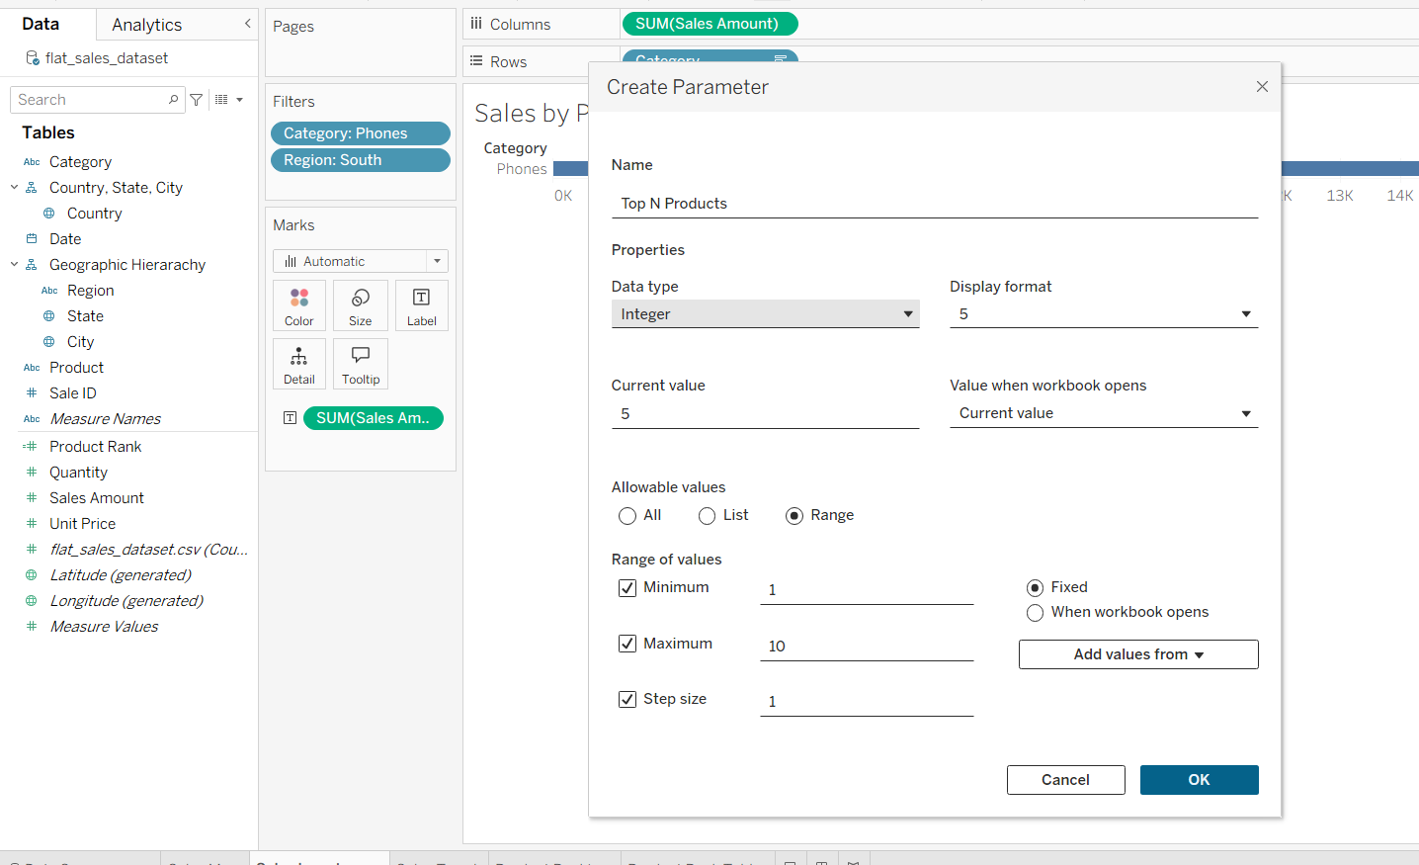

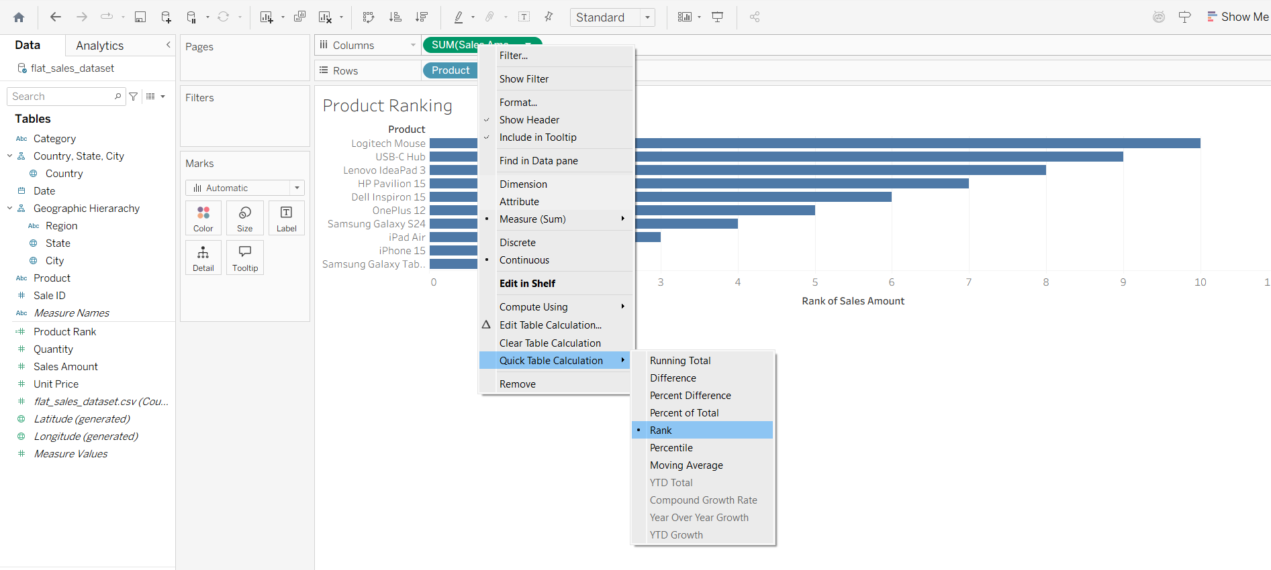

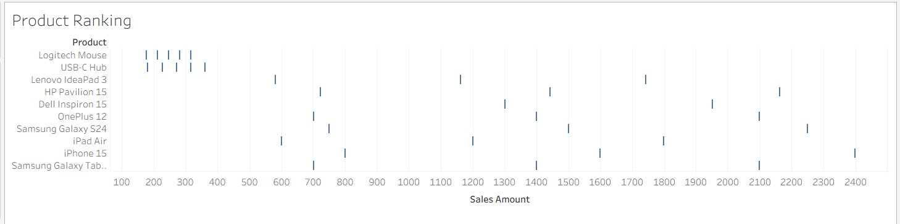

- Combine the worksheets into one dashboard with at least one action filter connecting them.

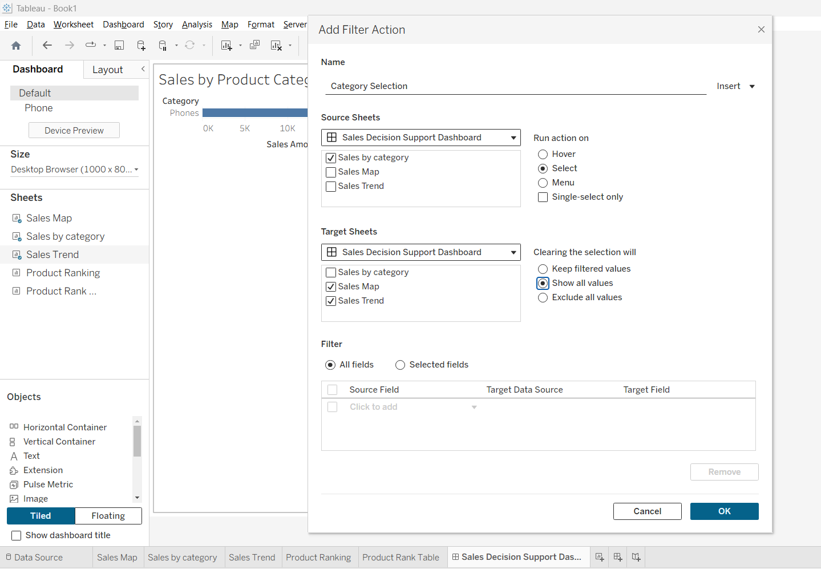

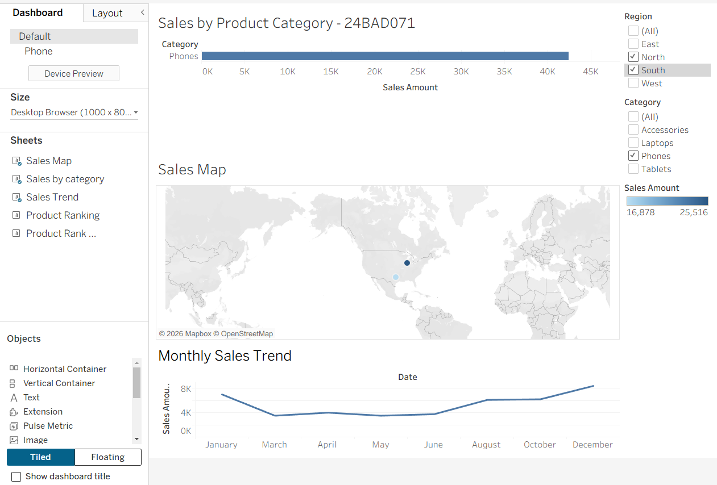

- Write a 200-word reflection: describe one specific decision a manager could make using this dashboard, and classify it as structured, semi-structured, or unstructured, with reasoning.

Reflection – Tableau Decision Support Dashboard
The Tableau dashboard can help a regional sales manager decide which products should receive additional promotional attention in a particular region. For example, the manager can select the South region and the Phones category using the dashboard filters. The manager can then examine the sales by location, compare product performance using the ranking view, and observe the sales trend over time. Based on this information, the manager could decide which phone products deserve greater promotional focus.
This is a semi-structured decision because the dashboard provides objective information that can support the decision, but the final decision still requires managerial judgment. The sales figures, product rankings, geographic information and trends provide measurable evidence. However, the manager may also need to consider factors outside the dashboard, such as competitor pricing, available inventory, marketing costs, customer preferences and expected future demand.
The dashboard's interactive features make the decision process easier. Filters allow the manager to slice the data to a single category and dice it using a combination of category and region. The RANK table calculation helps identify the best-performing products, while the action filter allows selections in one worksheet to affect the others. Therefore, the dashboard supports a semi-structured managerial decision by combining data-driven analysis with human judgment.

Deliverables
- The Tableau packaged workbook (.twbx).
- The 200-word written reflection.

Criterion | What to look for | Marks
Linked worksheets | Three distinct, well-chosen chart types, correctly linked | 5
Drill-down hierarchy | Hierarchy genuinely expands/collapses across at least two levels | 5
Filter and parameter (slice/dice) | Both work correctly and are distinguishable from each other | 5
Table calculation | RANK or running total calculation is correct and used meaningfully | 5
Dashboard and action filter | Views are combined into one coherent, interactive dashboard | 5
Decision reflection | Decision is specific, and the structured/semi/unstructured classification is justified | 5

ASSIGNMENT 3 — GEMINI-ASSISTED NOTEBOOK

Clean, Transform, Analyze
Concepts covered: the practical component (import, cleanse, transform), analytic functions, AI-assisted development.

Objective
Use a Gemini-assisted notebook (Google Colab, with Gemini as the in-editor coding assistant) to clean a messy dataset and implement the Python equivalents of SQL analytic functions — while critically reviewing the AI-generated code rather than accepting it blindly.

Tasks
- Open a new Google Colab notebook and load a deliberately messy version of the sales dataset (introduce a few missing values, an obvious outlier, and an inconsistent date format if your provided file doesn't already have them).
- Use Gemini's inline suggestions or chat panel to help write Pandas code that: (a) handles the missing values, (b) detects and handles the outlier, and (c) standardizes the inconsistent formatting.
- Transform the cleaned data into a shape suitable for BI reporting (for example, one row per Region × Quarter × Category with a summed Sales_Amount).
- Implement three analytic-function equivalents in Pandas, grouped by Region: a rank (.rank() or .groupby().rank()), a period-over-period comparison (.shift()), and a running total (.cumsum()).
- Ask Gemini to explain, in its own words, what one of your groupby/window code blocks does. Paste that explanation into a markdown cell, followed by a short note on whether it was accurate or needed correction.

Deliverables
- A shareable link to the completed Colab notebook (view access enabled).
- A short reflection (150–200 words) inside the notebook: where Gemini's suggestions were directly usable, and where the student had to fix or reject them.

Criterion | What to look for | Marks
Missing values handled | A clear, justified strategy is applied, not just dropped silently | 4
Outlier handling | Outlier is identified with a stated method and handled appropriately | 4
Format standardization | Inconsistent fields are cleaned into one consistent format | 4
Analytic-function equivalents | Rank, shift, and cumsum are all implemented correctly, grouped by region | 5
Gemini explanation + critique | Explanation is included and the accuracy critique is genuine and specific | 4
Overall reflection | Reflection distinguishes clearly between AI-assisted and selfcorrected work | 4

